Chapter 5, Problem 20

In the circuit in Fig. 5.59, calculate v_{o} if v_{s} = 2 V.

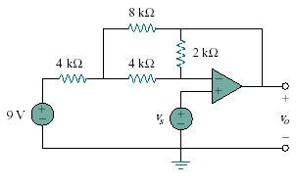
Figure 5.59
For Prob. 5.20.

